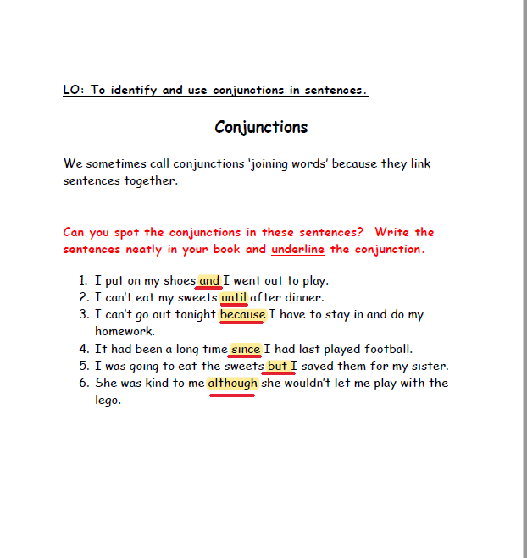

1. I can’t go swimming because, I am Sick.
2. Because my mum won’t let me.
3. The old woman wanted to feed her dog, but there was no food in the cabinet.
4. there was nothing in the cupboard, however there was some beans.

1. I bought some sweets and Chips.
2. but I ate them on the way home.